Infection Prevention and Control Guidance for Early Years Settings


Community Health Protection Team
June 2026
How to guide to infection prevention and control guidance for Early Years settings and Quality Officers | 3

Contents
This is an easy reference, ‘How To’ guidance for cleaning and preventing infection and transmission in early years settings. This guidance has been taken from (and to be used in conjunction with) Health protection in children and young people settings, including education.
Mini self-audit tool | 16
This is a tool for you and/or the EY Quality Officers to complete. This will help you to identify any areas that require improvement, which can then be added to an action plan and the required actions implemented. You can discuss the outcome of this with your Early Years Quality Officer.
Incident Management Team/ Multidisciplinary Team Meeting (IMT/MDT) | 20
There may be a time when EY setting staff are asked to attend an IMT meeting. This section provides information on what will be expected of staff and explains the IMT process.
Cleaning schedule template | 22
All settings should have a cleaning schedule in place to ensure that all equipment and areas are cleaned correctly. This will optimise infection prevention and control.
Management of cleaning equipment and products | 23

Management of blood & bodily fluid spills - nonhealthcare settings | 25

Safe management of waste (including sharps) | 26

Appendices
Appendix 1 | Handling sharps – poster for non-healthcare settings | 28
Appendix 2 | Laundry posters | 29
Appendix 3 | Safe management of environment and equipment | 31
Appendix 4 | Antimicrobial Stewardship Poster | 32
Appendix 5 | Report for support poster | 33

Acknowledgements
Greater Manchester Public Health Network (GMPHN) would like to thank the Manchester Health Protection Team for the development of this Infection Prevention and Control Guidance for the Early Years Setting. We also acknowledge the valuable contributions of the Manchester Early Years Quality Assurance Team and Manchester Environmental Health Team in supporting the development and review of the resource. Illustrations via freepik and storyset.

‘HOW TO GUIDE’ to INFECTION PREVENTION AND CONTROL GUIDANCE FOR EARLY YEARS SETTINGS and QUALITY OFFICERS
Table of Contents

Foreword 3
Preventing and reducing the risk of outbreaks of infection 3
Hand and respiratory hygiene 6
Cleaning of environment and equipment 7
Food preparation areas 7
General environment 8
Cleaning of handwash basins, toilets, potties and changing mats 10
Cleaning of toys, activity items and linens 11
Toys and activity items 11
Linens, cots and other items 11
Supervised toothbrushing schemes in early years and school settings 13
Avoiding cross-infection 13
Toothbrush storage system 13

Foreword
This document aims to provide a summary of actions as a minimum needed to help prevent the spread of infections in an Early Years setting. The guidance includes an overview of how infections can spread, what needs to be put in place to help prevent this, as well as information on basic IPC and cleaning, and useful resources.

Preventing and reducing the risk of outbreaks of infection
Ensuring that the Early Years setting has good infection prevention control systems in place can help break the chain of infection and reduce the risk of their spread and subsequent outbreaks. This can mean the difference between a setting remaining open or having to close to manage the outbreak. It’s important to ensure your staff have IPC training and therefore good understanding of infection control and cleaning procedures and follow a few simple rules.

CHAIN OF INFECTION AND HOW TO BREAK THE CHAIN
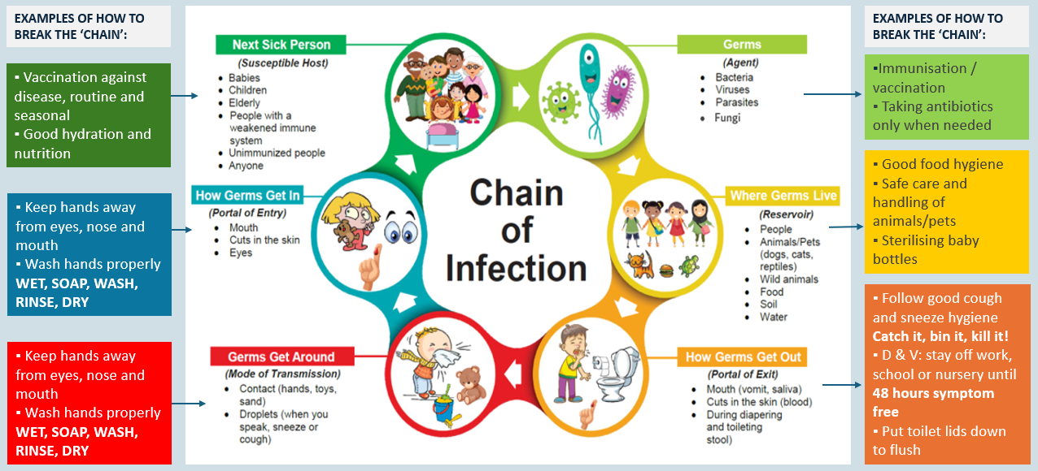
REMEMBER!

Personal protective equipment (PPE)
Staff should have easy access to readily available PPE and know how and when to wear it.

Cleaning schedules, equipment and products
Staff should have clear cleaning schedules, the right equipment and products and know how to clean. Managers should also have systems to check items are clean and that staff are following the schedules!

Immunisation
Education and childcare settings have a vital role to play in supporting the routine immunisation programme through sharing of information with parents and caregivers at key points. Settings may wish to speak to their health visitor, school nurse or other setting-specific healthcare worker about the support they can offer. Staff should also be up to date with the UK vaccination schedule.

MANAGING InfectionS AND PREVENTING THE SPREAD
It's important to have robust reporting procedures. Ensure parents and guardians know what your expectations are in regard to informing you if a child has an infection.
Communicate to parents and guardians about infections and how long children should stay away from nursery if they are unwell. Different infections need children to stay away for different lengths of time.
Health protection in children and young people settings, including education (GOV.UK) – this website contains information about the most common infections and how to manage them.

Report and support

Report infections to the Community Health Protection Team
Contact the Community Infection Control Team at CIPCT@boltonft.nhs.uk to report cases of infectious diseases within your setting or call 01204 390982 for an infection control query. Community Health Protection Team (CHPT) will review each report and provide support promptly.

Other Infections and Outbreaks Resources
- Guidance on infectious diseases:
Managing specific infectious diseases: A to Z - GOV.UK
- E-bug program:
Home (e-bug.eu)
- Information on farm visits:
How to stay safe from infections carried by animals when visiting a farm - GOV.UK

Hand and respiratory hygiene

Hand hygiene

WHAT YOU NEED TO KNOW | WHAT YOU NEED TO DO
Hand hygiene is one of the most important ways of controlling the  spread of infections. | Children and staff should have access handwash facilities that have liquid soap, warm water and paper towels and a waste bin.
 | Bar soap should not be used.
 | Alcohol hand gel can be used if hands are not visibly dirty.
 | Alcohol hand gel is not effective against organisms that cause diarrhoea and vomiting, such as norovirus.
 | Advise all individuals to wash their hands after using the toilet, before eating or handling food, after playtime and after touching animals.
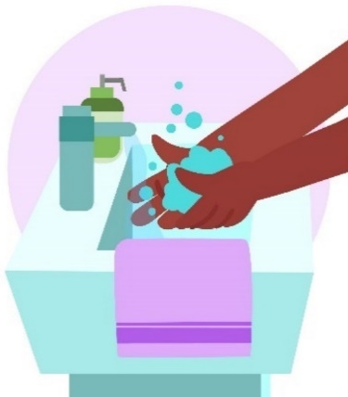 | Staff should keep nails short – avoid long or false nails and nail polish and should not wear jewellery or wrist watches.
 | Support children to learn the importance of hand hygiene (using resources such as e-bug).
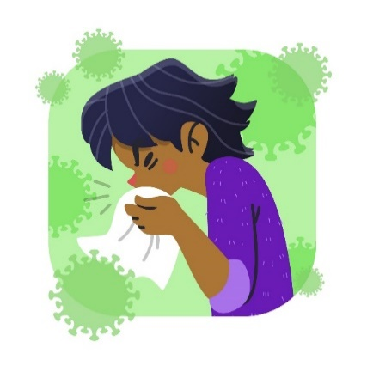

Respiratory hygiene

WHAT YOU NEED TO KNOW | WHAT YOU NEED TO DO
Coughs and sneezes  spread diseases | Discourage spitting.
Catch It! Bin It! Kill It! | Cover nose and mouth with a tissue when coughing and sneezing, dispose of used tissue in a waste bin, and clean hands. Support children in doing this.
Respiratory Hygiene (e-bug.eu)  EY Lesson plan | Keep contaminated hands away from eyes, mouth and nose.
Respiratory Hygiene (e-bug.eu)  EY Lesson plan | Clean hands after contact with respiratory secretions (cough or sneeze), used tissues, contaminated items or surfaces.

Cleaning of environment and equipment
NB: In an outbreak situation, more frequent, enhanced cleaning will be required.
It is important to ensure that any items soiled with blood or body fluids are cleaned with detergent, then disinfected, rinsed and dried. Refer to manufacturer instruction for specialist equipment.

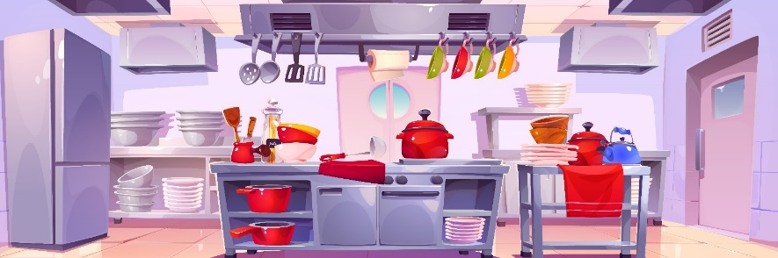
Food preparation areas

Food Hygiene | What you need to know | What you need to do
For further information please refer to Health protection in children and young people settings, including education (GOV.UK) – the information opposite has been taken from this document. | The Food Standards Agency (FSA) strongly advises the use of either a dishwasher, a sterilising sink, or a steam cleaner to clean and disinfect equipment and utensils. | Operate and maintain equipment according to the manufacturer’s instructions and include regular dishwasher interior cleaning cycles.  Follow food hygiene standards from the Food Standards Agency.  Educate children and young people on their role in improving food hygiene.  Contact the Environmental Health Department for further advice.

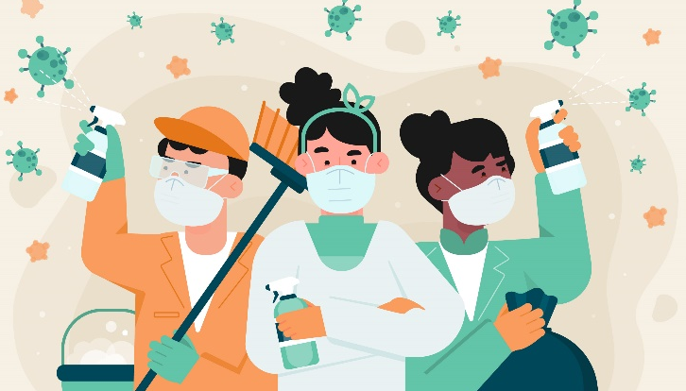
General environment

Area/ Item | How to clean/ care for | Frequency/ comments
Tables  Windowsills  Door and cabinet handles | Clean with neutral detergent, warm water and a clean cloth. | Daily, or immediately if soiled.
Highchairs  Dining tables | Clean with neutral detergent, warm water and clean cloth and dry with disposable paper towels. | Before and after use.
Washable floor covering  (see information on caring for cleaning equipment in the IPC pack) | Vacuum clean to remove dirt when children are not present.  Wash with detergent and warm water using clean mops and buckets. | Daily, immediately if soiled.  Vacuum daily.
Carpets | Carpets are not recommended, however if the setting has any carpeted areas, a steam cleaner should be used.  If carpets or soft furnishings are contaminated with body fluids, these should be steam cleaned | Vacuum or steam clean daily.  Clean carpets only when children are not present to ensure the carpet is dry before the next use.  Clean carpets at least monthly in infant areas, at least every 3 months in other areas, or immediately when soiled.
Small rugs | Launder. | Weekly, or when visibly dirty.
Spillages | Please note that some agents, such as NaDCC (Sodium Dichloroisocyanurate or Troclosene Sodium, a form of chlorine used for disinfection), cannot be used on urine. | Clean immediately.  See section:  Management of blood and body fluid spills in non-healthcare settings.
Walls and ceilings | Clean with warm water and general-purpose detergent.  If soiled with blood or body fluids, clean then disinfect. | Other than in areas of frequent hand contact, such as lower wall/door frames in areas occupied by toddlers, routine cleaning not required.
Waste bins | Clean with neutral detergent and warm water. | Empty daily.  Clean weekly, and immediately if soiled.
Safe management of waste (including sharps) |  | For waste management please refer to Safe management of waste section.

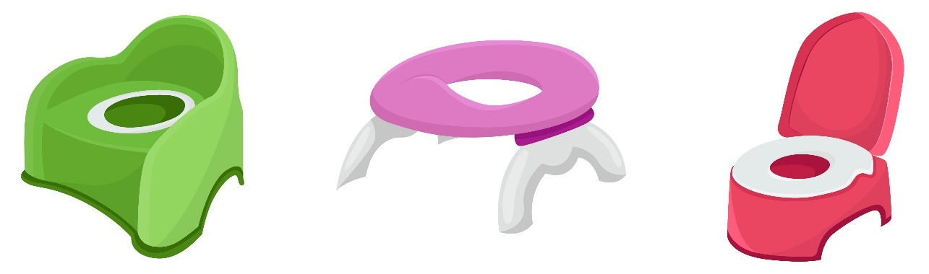
Cleaning of handwash basins, toilets, potties and changing mats

Area/ Item | How to clean | Frequency comments
Hand-wash basins | Clean hand-wash basins with detergent and warm water.  If soiled with blood or body fluids, clean as above then disinfect, rinse and dry. | At least daily and immediately if soiled.
Wall-mounted paper  towel dispenser  Soap dispenser  Foot-operated bin | Clean with detergent and warm water.  If soiled with blood or body fluids, clean as above then disinfect, rinse and dry. | At least daily and immediately if soiled.
Toilet seat, toilet handles, doorknobs or cubicle handles.  NB: Ensure toilet areas are free from any other items that might become contaminated, e.g. clothing, mops and buckets. | Clean with detergent and warm water.  If soiled with blood or body fluids, clean then disinfect, rinse and dry. | At least daily and immediately if soiled.
Toilet bowls | Use toilet cleaner as per manufacturer’s instructions. | At least daily and immediately if soiled.
Potties | Clean with detergent and warm water and if soiled, disinfect with a chlorine-based disinfectant with 1000 ppm available chlorine.  It should be noted that some agents, such as NaDCC (Sodium Dichloroisocyanurate or Troclosene Sodium, a form of chlorine used for disinfection), cannot be used on urine. | Immediately after each use.
Changing mats | Check for damage and replace if any damage visible. Clean after use with hot water and detergent. | After each use.


Cleaning toys, activity items and linens

Toys and activity items
Area/ Item | How to clean | Frequency comments
Soft toys | Machine washed in a hot cycle according to manufacturer's instructions. | Daily.  If soiled, take out of use immediately.
Hard toys and items | Clean with warm water and detergent, rinse and dry thoroughly. | This should be risk assessed. Daily for items children are putting in their mouths, and immediately if visibly soiled.
Other hard toys  E.g., doll houses, outdoor play items such as slides, climbing frames, etc. | Clean with warm water and detergent, rinse and dry thoroughly. | Weekly or immediately if soiled. Risk assess required frequency – it might need to be increased, e.g., when children have runny noses.
Sand pits  Water play/Play dough | Refer to manufacturer’s guidance.  Wash equipment with general purpose detergent and hand-hot water, after each session. Change daily or after each session. NB please refer to safety advice if using flour in Early Years Using flour in the early years: The latest FSA guidance 2024 - Blossom Educational  Dry the equipment thoroughly with paper towels or a clean towel that you can wash immediately after using it. | Check and clean regularly, immediately if visibly dirty or contaminated.  Suspend during outbreaks of infectious disease - liaise with CHPT.

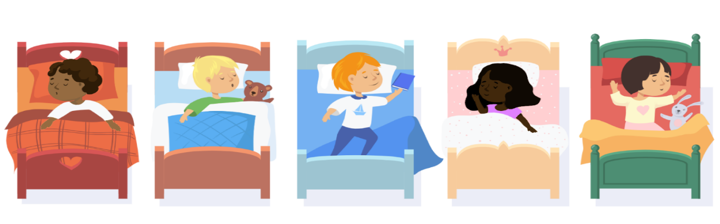
Linens, cots and other items
Area/ Item | How to clean | Frequency comments
Linens  - Bedding: sheets and pillowcases, blankets, sleeping bags  - Individual cloth towels  - Face cloths  - Other fabrics  (None of these items above should be shared among children) | Bedding should be allocated to a named person.  Launder face cloths after each use.  Remove dirty and used linen from areas that are accessible to children and young people.  Wash all linen at the hottest temperatures specified on the fabric.  Keep fresh linen in a clean, dry area separate from used linen.  Ideally, red soluble linen bags should be used for transferring and washing soiled linen. | Weekly or after each use if used by different children.  Take out of use immediately when visibly soiled.
Clothing  including reusable nappies, children's own clothing and fabric aprons (if worn by staff) | Carefully dispose of any soiling (i.e., faeces) found on clothing or linen into the toilet, for example from reusable nappies.  Note: do not rinse soiled clothing, including reusable nappies. | Take out of use immediately when visibly soiled and/or contaminated.
Disposable Nappies |  | Dispose into offensive waste or appropriate waste stream
Combs and hairbrushes | Clean with detergent and warm water. | Ideally not shared between children. If shared, clean between each use.
Cots and cot mattresses | Check for and replace in case of visible damage. Clean with detergent and warm water, rinse and dry. | Weekly, before use by a different child, and immediately if soiled or wet.
Staff uniforms | Please refer to staff uniform policy which should include washing instructions, and to have a change of uniform available in setting if needed. | Daily or change immediately if soiled during shift.

Supervised toothbrushing schemes in early years and school settings

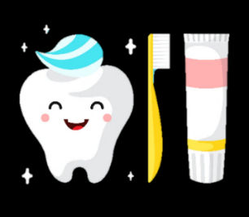
Avoiding cross-infection
Good hygiene practice should be an essential part of childcare in nursery and school settings. Toothbrushes are a possible source of cross-infection. Toothbrush storage systems comply with best practice in the prevention of cross-contamination.
Children returning to the setting after being unwell can participate in the supervised toothbrushing scheme without delay unless otherwise stated by specific locally implemented precautions and guidelines. If there is suspicion of or a confirmed case of a notifiable disease, seek and follow the advice of the local health protection team.

Toothbrush storage systems
Toothbrushes should be stored in appropriate storage racks, systems or individual ventilated holders that enable brushes to stand upright and not be in contact with each other, to avoid cross-contamination. The standards apply equally to individual holders as to the storage systems.
- The storage system lids or covers are not interchangeable and should always be put back facing the same direction.
- Storage systems display symbols corresponding with those on the toothbrushes to allow individual identification. Each toothbrush should always be replaced into the same hole in the storage system following toothbrushing.
- Storage systems should allow airflow around the toothbrush heads to enable the toothbrushes to dry. Covers should only be used once brushes have dried, or if they allow sufficient ventilation to allow drying.
- Storage systems should be stored within a designated toothbrush storage trolley or in a clean, dry cupboard and:
  - have manufacturers’ covers that allow the free flow of air
  - be stored at adult height or in a suitable toothbrush storage trolley
- Dedicated household gloves should be worn when cleaning storage systems and sinks. After toothbrushing, sinks should be cleaned with neutral detergent or wipes.
- Storage systems, trolleys and storage areas should be cleaned, rinsed and dried at least once a week (more if soiled) by staff using warm water and household detergent. Manufacturers’ guidelines should be followed when cleaning and maintaining storage systems, including dishwasher cleaning where appropriate. Disinfectant wipes are not recommended for cleaning storage systems.
- The storage system should not be placed directly beside where toothbrushing takes place to avoid contamination via aerosol spread.
- Storage systems should be replaced if cracks, scratches or rough surfaces develop.

Steps involved in supervised toothbrushing
The following steps include the general infection prevention and control criteria and are appropriate for either approach that is implemented.

Step 1: Wash or Sanitise Hands
Supervisors and children (under supervision) should wash their hands or use hand sanitiser before and after the toothbrushing session. Supervisors should cover any cuts, abrasions or breaks in their skin with a waterproof dressing before starting a toothbrushing session and before carrying out cleaning.
There is usually no need for the supervisor to wear personal protective equipment (PPE) such as aprons and gloves. The supervisor can, however, choose to wear PPE if they deem the likelihood of exposure to bodily fluids (for example saliva and blood) to be increased. If deemed necessary due to the likelihood of exposure, one pair of gloves should be used per child, and the supervisor needs to wash or disinfect hands between glove changes (after taking gloves off and before putting a new pair of gloves on). Aprons should be changed when they become heavily soiled or contaminated with bodily fluids such as saliva or blood.

Step 2: Collect Toothbrushes
The children under supervision collect their toothbrushes from the storage system, along with a tissue or paper towel so they can spit any excess toothpaste into this after brushing. Toothbrushes must be individually identifiable, enabling each child to be able to recognise their own brush. Discretion should be used if a child has additional support needs.

Step 3: Dispense Toothpaste
When a toothpaste tube is shared, the toothpaste must not be dispensed directly onto the toothbrushes. Supervisors should dispense the toothpaste onto a clean surface such as a plate or individual paper towel or tissue square to allow each child to apply the toothpaste to their brush. Toothpaste paper should be disposed of immediately in a waste bag.
There must be sufficient spacing between the quantities of dispensed toothpaste to allow transfer to each child’s brush without cross-contamination. When a reusable plate is used to dispense the toothpaste, it should be cleaned and washed afterwards at high temperatures. Paper or plastic plates should be disposed of immediately in a waste bag.
A smear of toothpaste is used for children under 3, and a pea-sized blob for children aged 3 to 6 years.
Tissues or paper towels must be disposed of immediately after use in a refuse bag.

Step 4: Supervise Toothbrushing
Children to brush their teeth - the observing supervisor must ensure teeth are brushed effectively, following the training they have received.

Step 5: Rinse Toothbrushes
At the end of the toothbrushing session, observed by the supervisor, the toothbrushes must be rinsed.
The infection prevention and control steps for cleaning and handling toothbrushes should be followed. Toothbrushes should be rinsed straight away. The toothpaste should not be allowed to dry on the brush. Toothbrushes should not be washed together in the sink and should not touch the taps or sink when being rinsed.
There are two approaches for rinsing toothbrushes:

Supervisor rinses toothbrushes:
Toothbrushes can be returned to the storage system by each child and taken to the identified sink area by the supervisor. The supervisor is responsible for rinsing each toothbrush and its handle at a sink under cold running water. After rinsing the toothbrushes, the supervisor is responsible for shaking off excess water into the sink. Toothbrushes should not come into contact with the sink or tap at any point during the session. Discretion should be used if a child has additional support needs.
Routinely, if the supervisor rinses the toothbrushes, there is no need for them to wear PPE. If the toothbrushes are heavily contaminated (including the bristles and the handle), the supervisor should consider wearing gloves and apron. In that case, one pair of gloves should be used per toothbrush, and the supervisor needs to wash or disinfect hands between glove changes (after taking gloves off and before putting a new pair of gloves on). Aprons should be changed when they become heavily soiled or contaminated with bodily fluids (for example saliva or blood).

Child rinses their own toothbrush:
Toothbrushes can be rinsed at an identified sink area where each child is responsible for rinsing their own toothbrush. Each child should in turn rinse their own toothbrush and its handle at a sink under cold running water. After rinsing the toothbrushes, the child or the supervisor is responsible for shaking off excess water into the sink. Discretion should be used if a child has additional support needs.

Step 6: Return the Toothbrushes to the Storage Area
Each child under supervision of the supervisor should be responsible for returning their own toothbrush to the storage system to air dry. Toothbrushes should not touch other toothbrushes or storage system lids or covers at any point during or between sessions. Discretion should be used if a child has additional support needs. If the lids are used for the storage system, they should be replaced at this stage if there is sufficient air circulation to allow the toothbrushes to dry before the next use.
Toothbrushes must not be soaked in bleach or other cleaner or disinfectant. Paper towels should be used to mop up all visible drips on the storage system. Toothbrushes that are dropped on the floor should be discarded.

Step 7: Clean the Toothbrushing Area
After toothbrushing, supervisors should clean the area where the toothbrushing has taken place with detergents and bleach. Supervisors are also responsible for cleaning sinks and surfaces following national guidance and using standard cleaning products such as detergents and bleach.

MINI SELF – AUDIT TOOL
Early Years Quality Officer IPC questions and setting self audit tool
Please tick Yes or No and/or add comments, these comments can be useful when reviewing the audit outcome with your Quality Assurance Officer.

1. Environment
Is the environment visibly clean, not cluttered, furniture in good state of repair; is there an odour?
Yes ☐ | No ☐ | Comments

2. Cleaning schedule/cleaning materials
Is there a cleaning schedule that shows what to clean and when, and a daily record of cleaning – evidence of quality assurance, appropriate use of cleaning equipment and materials – COSHH?
Control of Substances Hazardous to Health (COSHH) - HSE
Yes ☐ | No ☐ | Comments

3. Cleaning products storage
Are cleaning products stored correctly?
Please refer to: Control of Substances Hazardous to Health (COSHH) - HSE
Yes ☐ | No ☐ | Comments

4. Hand Hygiene (Inside and outdoors)
Hand washing - one of the single most important measure to reduce
the spread of infection
Are hand washing facilities available throughout, liquid soap and paper towels available, sinks clean and bins in working order; children and staff supported to routinely wash hands, hand washing signage displayed?
See e-bug resource: Hand Hygiene (e-bug.eu)
Yes ☐ | No ☐ | Comments

5. Care of play equipment
Are wipeable shared toys cleaned regularly and in good state of repair; sandpits sieved daily, covered when not in use and changed regularly, and water play emptied after each use and cleaned thoroughly; homemade play dough made prior to play and disposed of afterwards? Water, sand and play dough suspended during outbreak?
Yes ☐ | No ☐ | Comments

6. Nappy changing area
Is there a designated area; clean and uncluttered with hand washing facilities, are changing mats clean and intact, staff have easy access to and use PPE (risk assessed) hands washed correctly before and afterward nappy changing?
Yes ☐ | No ☐ | Comments

7. Potties
Is the designated area clean and uncluttered with hand washing facilities; use of PPE, hand washing after? Potties cleaned after use and stored safely?
Yes ☐ | No ☐ | Comments

8. Toilet areas
Are child sized toilets with lids, clean and odour free, handwash facilities with plentiful supplies of liquid soap, paper towels and toilet tissue, poster displayed advising how to wash hands?
Yes ☐ | No ☐ | Comments

9. Preparation and storage of milk/ food preparation
Food preparation areas/ storage of milk equipment is clean, wiped down after use, hands washed before handling, correct storage of milk and foods? Safe preparation of snacks?
Refer to Food safety - Help for early years providers - GOV.UK and Expressing and storing breast milk - NHS.
Yes ☐ | No ☐ | Comments

10. STORAGE OF DUMMIES, CUPS WITH LIDS AND BOTTLES
Are dummies, cups with lids, bottles stored safely and labelled with the child’s name to avoid sharing?
Yes ☐ | No ☐ | Comments

11. IPC Policies in place
Do you have IPC policies and procedures in place such as outbreak management policy?
Refer to Preventing and controlling infections - GOV.UK.
Yes ☐ | No ☐ | Comments

12. E-BUG
Is the setting aware of and using the E-bug resources for early years?
Visit E-bug website (www.e-bug.eu)
Yes ☐ | No ☐ | Comments

13. Identifying and reporting of infectious symptoms
Are staff aware of how to spot the signs of infection, manage specific infectious diseases (with the support from Community Health Protection Team) and know how to report them?
- Refer to Managing specific infectious diseases: A to Z - GOV.UK.
- E-mail CIPCT@boltonft.nhs.uk for further advice.
Yes ☐ | No ☐ | Comments

14. Vaccinations
Does the setting actively encourage and promote the UK vaccination programme for staff and children?
See link: NHS vaccinations and when to have them - NHS.
Yes ☐ | No ☐ | Comments

15. Training
Do staff receive training on infection prevention and control and is this recorded on a training plan/matrix?
Yes ☐ | No ☐ | Comments

16. Infection Prevention Control Lead
Does the setting have a member of the team who leads on infection Prevention and Control? (for sharing information, communicating to others the importance of Infection Prevention and Control)
Yes ☐ | No ☐ | Comments

OUTCOME (Quality Assurance Officers - Refer to process flowchart)
Are there any IPC concerns?
Yes ☐ | No ☐
List below and any actions

IMT/MDT meetings

Information for settings

What is an IMT/MDT?
- IMT - Incident Management Team Meeting
- MDT - Multidisciplinary Team
If there is a case/s of infection or an outbreak that requires further support and management, you may be invited to an IMT or MDT meeting, which can be organised by your local Health Protection Team or UK Health Security Agency (UKHSA; formerly Public Health England).
This simply means that different professionals will come together with staff from the setting to discuss the outbreak and decide on the best plan of action to support the setting with managing the outbreak. The IMT/MDT meeting is a supportive process.
Settings required to attend an MDT can get support from the Health Protection team and the Early Years Quality Assurance Team.

Before the meeting
As a member of staff from the setting, you may be asked to provide information and therefore it is useful for you to have the following prepared:

- The type of setting, for example nursery or special school, layout – how many rooms, etc.
- Total numbers attending (children, young people and staff)
- Total numbers affected
(children, young people and staff and if anyone in the household is affected)
- Any food handlers affected
- The number of classes, rooms, year groups affected (including nursery if applicable)
- The symptoms experienced
- The date when symptoms started, including a brief overview of the sequence of numbers of new cases since the outbreak started
- Any indications of severe disease such as overnight admissions to hospital
- If there were any events or trips in the week prior to the start of the outbreak
- If known, whether any tests or clinical assessments have taken place
- Vaccination uptake (for example for MMR and other infections)
- If there are any individuals within the affected group at higher risk from severe disease
- The measures you already have in place to reduce the risk of further spread, e.g., cleaning, promoting handwashing

After the meeting
Actions following the meeting may include:
- Setting being given warn and inform letters to share with parents/carers (this tells parents/carers that there is a confirmed positive case/s for a particular infection and tells them what to look out for and what to do if their child does develop symptoms)
- Setting being asked to enhance infection prevention and control measures (your local Health Protection team can support you with this)
- Vaccination sessions being offered within the setting
- A supportive visit by local health protection team to help with infection prevention control measures
Following the meeting, the setting will continue to be supported by their local health protection team and/or UKHSA until the outbreak has ended.

Cleaning schedule template
Area/Item  to be cleaned | Frequency | Days of the week |  |  |  |  |  |  | Manager’s Signature
Area/Item  to be cleaned | Frequency | Mon | Tue | Wed | Thu | Fri | Sat | Sun | Manager’s Signature

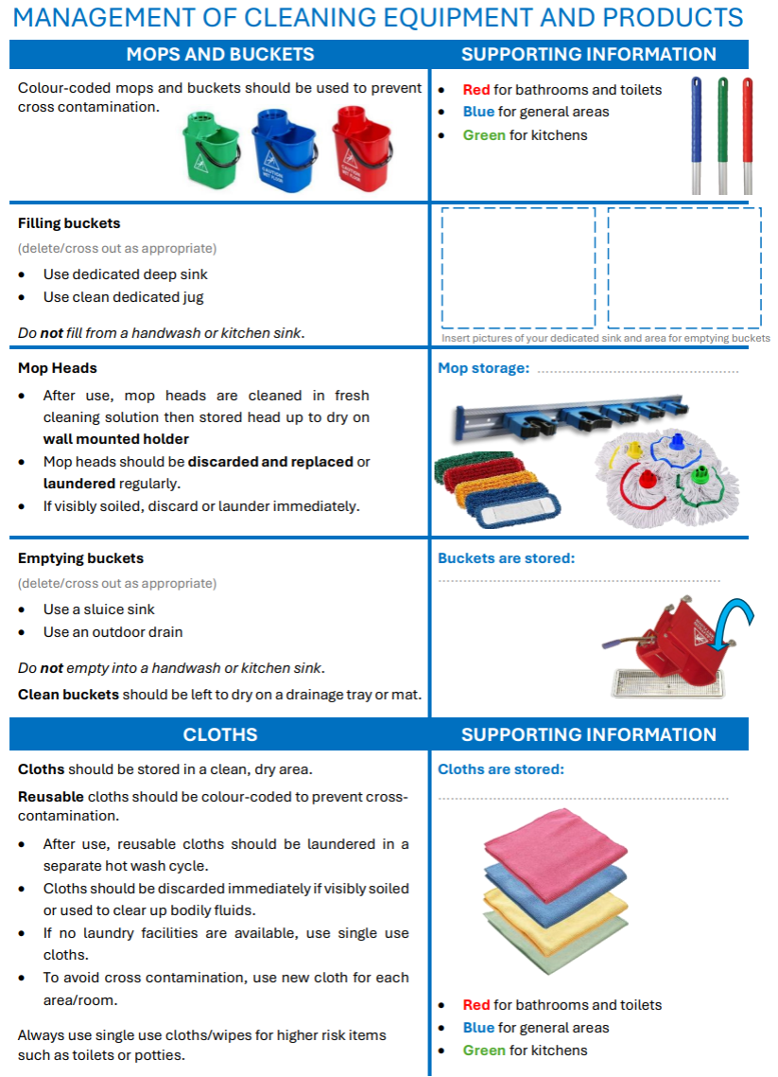
port for Management of cleaning equipment and products
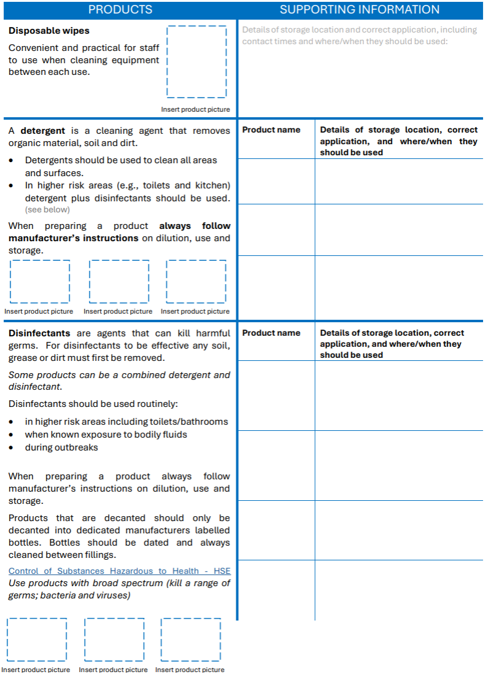

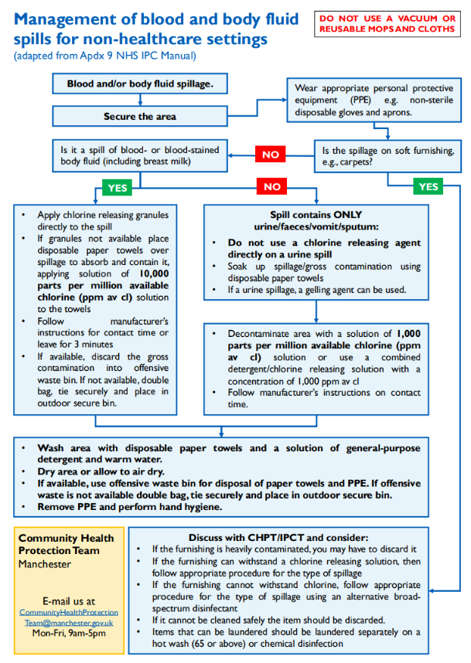
Management of blood and body fluid spills for non-healthcare settings
Email: CIPCT@boltonft.nhs.uk
Call: 01204 390982

Safe management of waste (including sharps)
All information has been taken from Preventing and controlling infections - GOV.UK.

Waste
Under the waste management duty of care, settings must ensure that all waste produced is dealt with by a licensed waste management company.
Place any used PPE in a refuse bag and dispose of as normal domestic waste. PPE should not be put in a recycling bin or dropped as litter.
Settings that generate clinical waste should continue to follow usual waste policies.
Nappy waste can sometimes be produced in large quantities in places such as nurseries. Although considered non-hazardous it can sometimes be offensive and cause handling problems. Contact your local authority if you are a setting that produces significant amounts of used nappies (more than 7kg per collection period) to discuss appropriate disposal arrangements.

Sharps
All settings should have a policy in place to support the safe management of sharps.
All staff should be educated in the safe handling and disposal of sharps. In a nursery setting sharps are items that could cause cuts or puncture wounds. These could be unexpected items such as syringes discarded in a play area.
If sharps are not handled and disposed of correctly they can result in harm to the handler with a risk of infection if an injury is sustained by mishandling: see Appendix 1: Handling sharps - poster for non-healthcare settings.

What you need to know
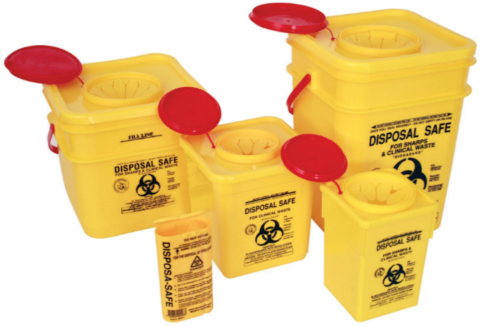
An exposure is an injury from a used needle or a bite which breaks the skin, and/or exposure of blood and body fluids onto:
- broken skin
- the eyes, nose or mouth
Human mouths are inhabited by a wide variety of organisms, some of which can be transmitted by bites. Human bites resulting in puncture or breaking of the skin are potential sources of exposure to blood borne infections, therefore, it is essential that they are managed promptly.

What you need to do
If someone pricks or scratches themselves with a used hypodermic needle or has a bite which breaks the skin:
  - dispose of the needle safely in a sharps container to avoid the same thing happening to someone else – please contact your local authority or school nurse for help with safe disposal of discarded needles
  - wash the wound thoroughly with soap and warm running water
  - cover the wound with a waterproof dressing
  - seek immediate medical attention or advice from your local accident and emergency department or occupational health provider

Record it in the accident book and complete the accident form.
If you have any issues or queries about sharps management, please contact Sharps on 0800 731 9835 for response and advice.

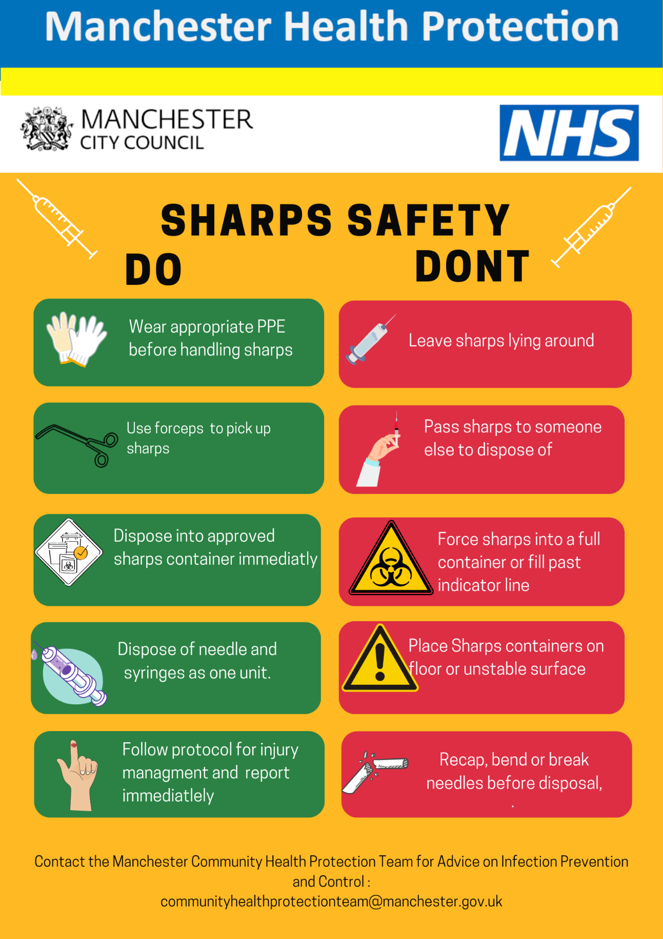
Appendix 1 – Handling sharps – poster for non-healthcare settings

Appendix 2 – Laundry posters
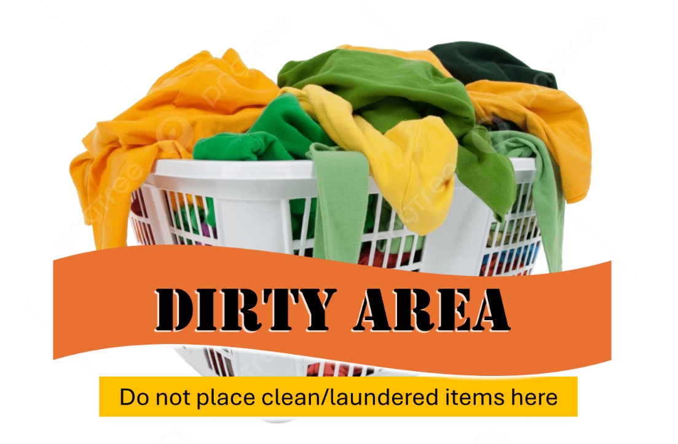
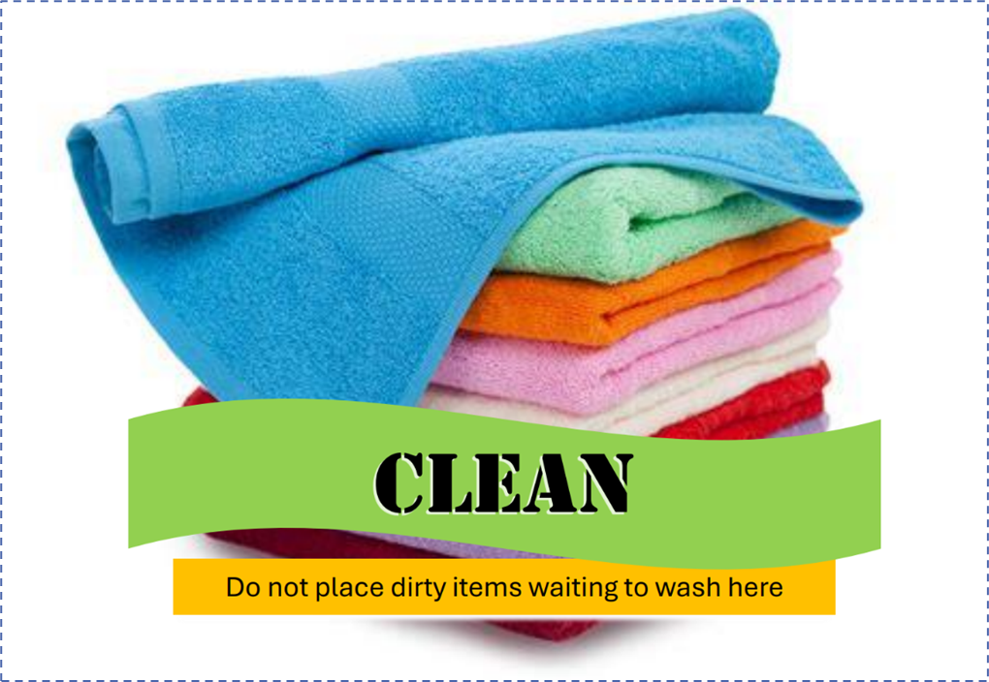
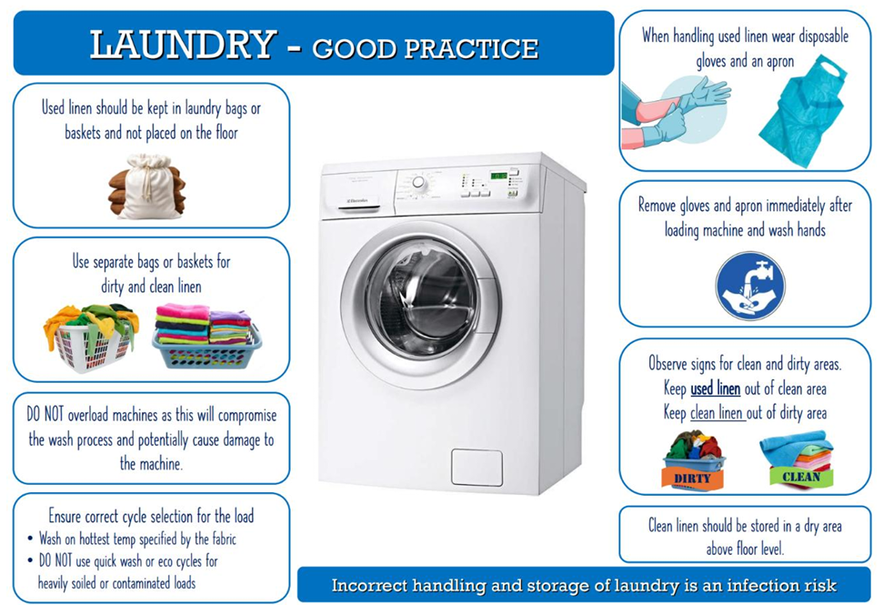

APPENDIX – 3 Safe management of ENVIRONMENT AND EQUIPMENT
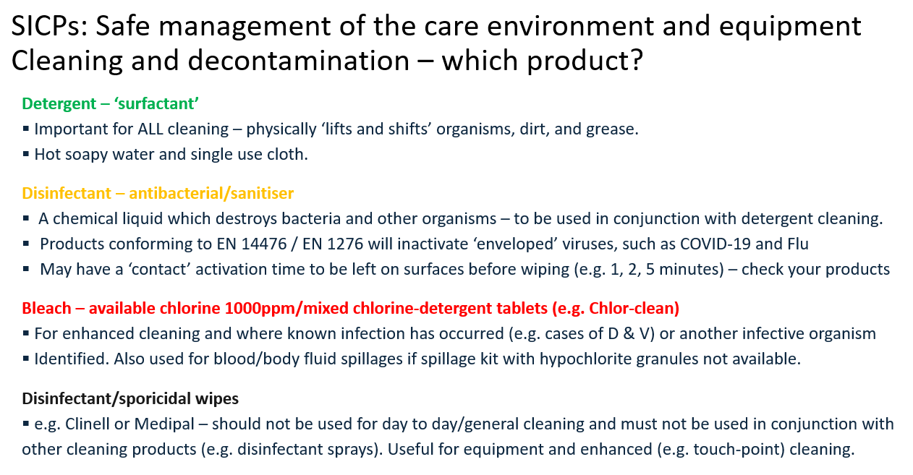

APPENDIX 4 Antimicrobial Stewardship POSTER
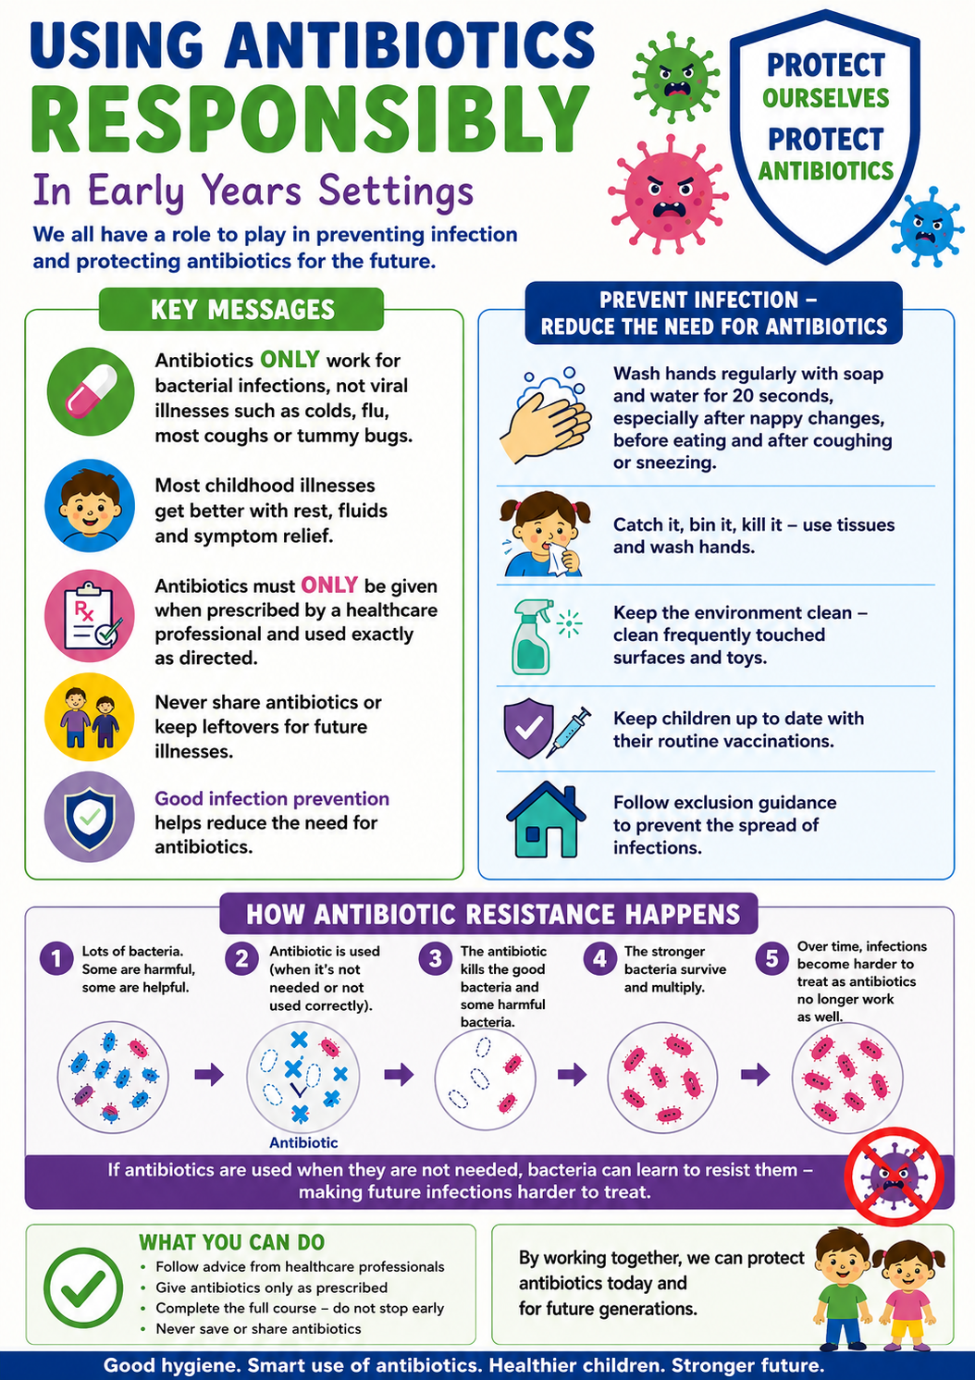

APPENDIX 5 REPORT TO SUPPORT POSTER

Community Infection Control Team – 9am-5pm Mon-Fri
CIPCT@boltonft.nhs.uk
01204 390982

Health Protection Team (Bolton Council) – 9am-5pm Mon-Fri
healthprotection@bolton.gov.uk
01204 336004

UKHSA – Out of hours
03442 250 562

